***BE LAB Task # 11***

***Name: Shahmeer khan.***

***Class ID: 106293.***

***Student Id: 12113.***

***Topic: Introduction to Transistor.***

***Objectives:***

1. IDENTIFICATION OF TRANSISTOR TYPE ( NPN, PNP ) AND TERMINALS (COLLECTOR, BASE, EMITTER) OF A684 AND C945.
2. DEMONSTRATE AND MEASURE THE EFFECTS OF BASE ON COLLECTOR CURRENT OF FORWARD AND REVERSE BIAS IN THE EMITTER-BASE CIRCUIT.
3. DEMONSTRATE AND MEASURE THE EFFECTS OF BASE ON COLLECTOR CURRENT OF FORWARD AND REVERSE BIAS IN THE EMITTER-BASE CIRCUIT.
4. DEMONSTRATE AND MEASURE THE EFFECTS OF BASE ON COLLECTOR CURRENT OF A CHANGE IN COLLECTOR VOLTAGE.

***Objectives A:***

IDENTIFICATION OF TRANSISTOR TYPE ( NPN, PNP ) AND TERMINALS (COLLECTOR, BASE, EMITTER) OF A684 AND C945.

|  |  |  |
| --- | --- | --- |
| **TERMINALS** | **A684**(PNP) | **C945**(NPN) |
| LEFT LEAD | Emitter | Emitter |
| MIDDLE LEAD | Collector | Base |
| RIGHT LEAD | Base | Collector |

***Objectives B:***

DEMONSTRATE AND MEASURE THE EFFECTS OF BASE ON COLLECTOR CURRENT OF FORWARD AND REVERSE BIAS IN THE EMITTER-BASE CIRCUIT.

BY USING NPN TRANSISTOR

|  |  |  |  |  |  |
| --- | --- | --- | --- | --- | --- |
| IB  mA | VBE | |  | VBE | |
| Q1 | Q2 | Q1 | Q2 |
| 0.02 | **512.16** |  | 0.4 | **589.349** |  |
| 0.04 | **529.74** |  | 0.6 | **599.768** |  |
| 0.06 | **540.612** |  | 0.8 | **607.346** |  |
| 0.08 | **547.725** |  | 1.0 | **613.075** |  |
| 0.1 | **553.589** |  | 2.0 | **630.933** |  |
| 0.2 | **571.715** |  | 3.0 | **641.403** |  |

BY USING THE FOLLOWING VALUES FOR VOLTAGE AND SETTING RESISTANCE AT 10K Ω.

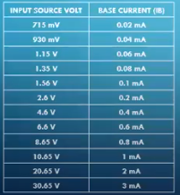

* ***Screen-Shots:***

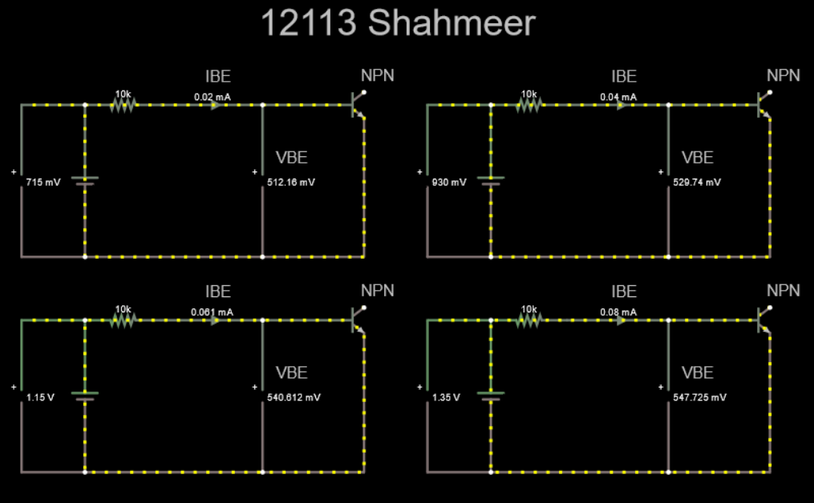

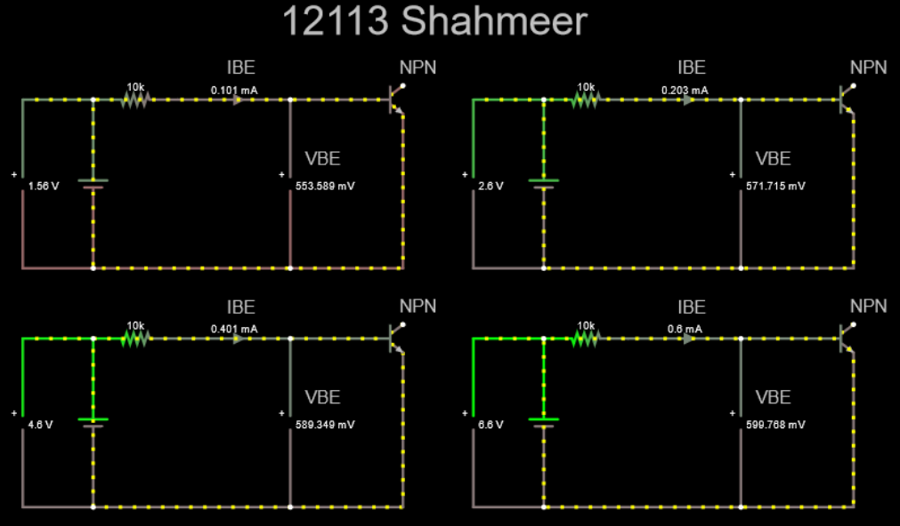

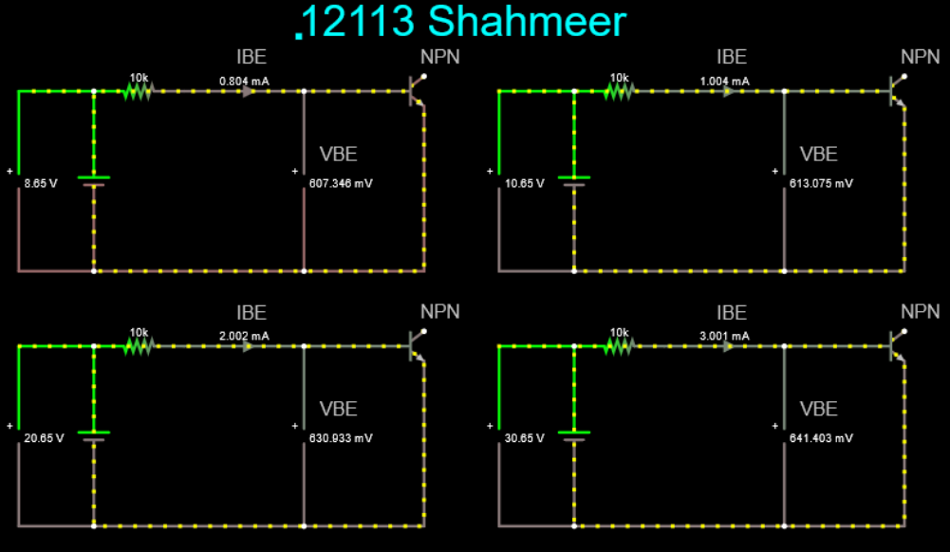

* ***Link:***

<https://tinyurl.com/ygr48xg5>

* REPEATING THE SAME PROCESS WITH PNP TRANSISTORS:

BY USING PNP TRANSISTOR:

|  |  |  |  |  |  |
| --- | --- | --- | --- | --- | --- |
| IB  mA | VBE | |  | VBE | |
| Q1 | Q2 | Q1 | Q2 |
| 0.02 |  | **512.16** | 0.4 |  | **589.349** |
| 0.04 |  | **529.74** | 0.6 |  | **599.768** |
| 0.06 |  | **540.612** | 0.8 |  | **607.346** |
| 0.08 |  | **547.725** | 1.0 |  | **613.075** |
| 0.1 |  | **553.589** | 2.0 |  | **630.933** |
| 0.2 |  | **571.715** | 3.0 |  | **641.403** |

* ***Screen-Shots:***

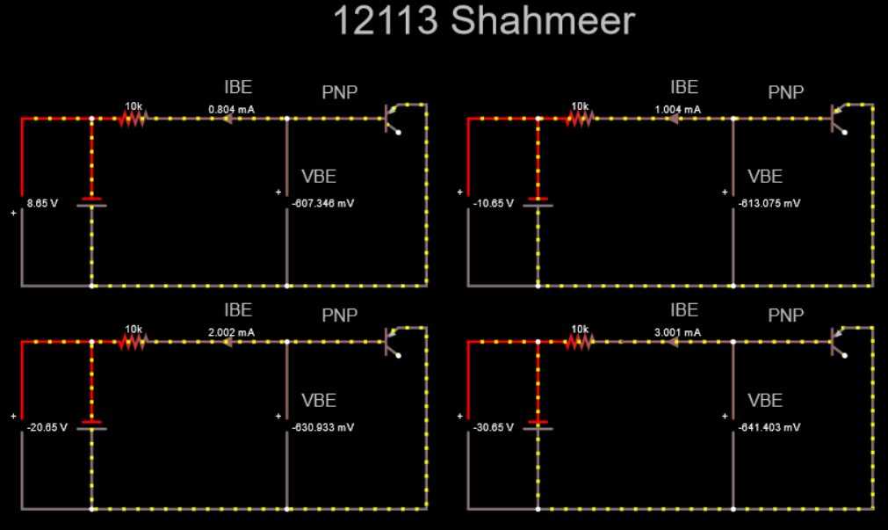

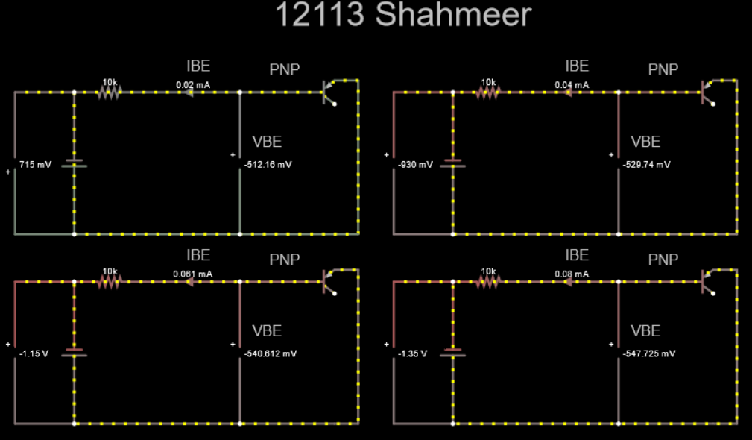

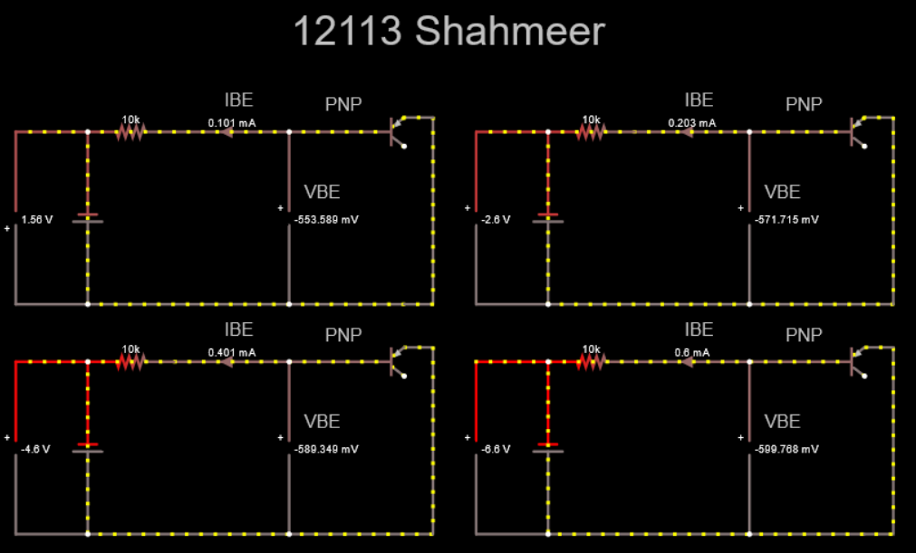

* ***Link:***

<https://tinyurl.com/yehfesmu>

*) IEBO = - 1.581micro A dc.

*) EXAMINE YOUR RECORDED DATA IN TABLE 1, IS THERE ANY SIMILARITY BETWEEN THE FORWARD VOLTAGE DROP FOR SILICON TRANSISTOR Q1 AND A SILICON DIODE?

*) AT APPROXIMATELY WHAT VOLTAGE IS THE BASE TO EMITTER OF Q1 COMPLETELY OF FORWARD BIASED?

VBE (SILICON) = 0.7 Vdc.

*) AT APPROXIMATELY WHAT VOLTAGE IS THE BASE TO EMITTER OF Q2 COMPLETELY OF FORWARD BIASED?

VBE (GERMINIUM) = 0.3Vdc.

***Objectives C:***

DEMONSTRATE AND MEASURE THE EFFECTS OF BASE ON COLLECTOR CURRENT OF FORWARD AND REVERSE BIAS IN THE EMITTER-BASE CIRCUIT.

|  |  |
| --- | --- |
| COLLECTOR CURRENT (IC) | BASE CURRENT (IB) |
| 1. m A dc | 0 micro Amp |
| 2 m A dc | 22.419 m Amp |
| 4 m A dc | 39.793 m Amp |
| 6 m A dc | 57.386 m Amp |
| 8 m A dc | 83.229 m Amp |
| 10 m A dc | 99.968 m Amp |

* Screen-Shots:

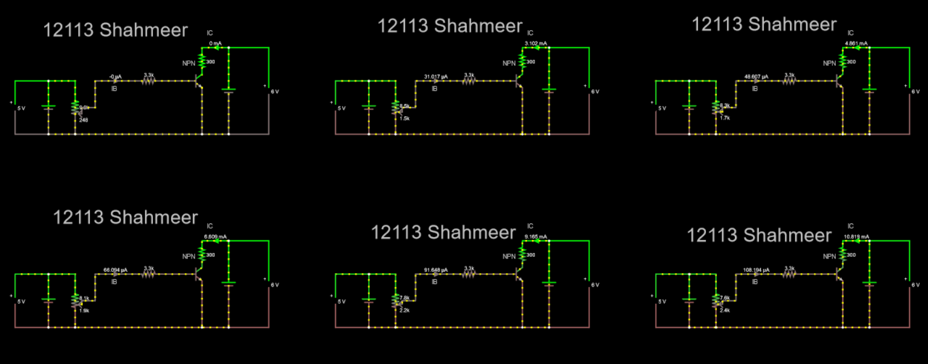

*) EXAMINE THE RESULT SHOWN IN DATA 2. DOES A SMALL CHANGE IN BASE CURRENT CAUSE A LARGE CHANGE IN COLLECTOR CURRENT ?

ANS: YES

*) WHAT CHANGE IN BASE CURRENT IS REQUIRED TO CHANGE THE COLLECTOR CURRENT FROM 2mAdc to 10mAdc ? THE GREEK LETTER DELTA MEANS “CHANGE IN”.

***Solution:***

Since, (DELTA) IB = IB (AT IC = 10 mA ) - IB (AT IC = 2 mA)

HERE,

IB (AT IC = 10 m A )= 99.968 m Amp

IB (AT IC = 2 m A) = 22.419 m Amp

SO,

(DELTA) IB = 99.968-22.419

(DELTA) IB = 77.549 m A dc.

* ***Link:***

<https://tinyurl.com/yhpjqyum>